GitHub Actions

Foundations & Architecture

1.1 GitHub Actions vs Jenkins: Quick Reference
What You Know from Jenkins Jenkins Architecture:
┌─────────────────────────────────────────┐
│ Jenkins Controller │
│ (GUI, Scheduling, Job Management) │
└──────────────────┬──────────────────────┘
│
┌──────────┼──────────┐
│ │ │
┌──┴──┐ ┌──┴──┐ ┌──┴──┐
│Agent│ │Agent│ │Agent│
│ #1 │ │ #2 │ │ #3 │
└─────┘ └─────┘ └─────┘ Jenkins Pipeline Structure:
pipeline { agent any stages { stage('Build') { ... } stage('Test') { ... } stage('Deploy') { ... }
}
}

1.2 Concept Mapping: Jenkins → GitHub Actions Jenkins Concept GitHub Actions Equivalent Purpose

Job | Workflow | Top-level automation unit
Pipeline | Workflow | Declarative pipeline definition
Stage | Job | Logical grouping of steps
Step | Step | Individual command or action
Plugin | Action | Reusable task from marketplace
Agent | Runner | Machine executing the job
Credential | Secret | Protected environment variable
Jenkins Concept GitHub Actions Equivalent Purpose

Parameter Input User-provided or context value
Trigger Event (on:) What causes the workflow to run

1.3 Core Definitions

Workflow
A YAML file in .github/workflows/ that defines an automated process. It contains: - Triggers (events): when to run - Jobs: logical units of work - Steps: individual commands or actions
File Location: .github/workflows/my-workflow.yml Minimum YAML Structure:
name: My First Workflow on: push jobs: my-job:
runs-on: ubuntu-latest steps:
- run: echo "Hello GitHub Actions!"

Job
A set of steps executed on the same runner. Key characteristics: - Jobs run in parallel by default (unlike Jenkins stages) - Can have dependencies using needs: - Run on a specific runs-on: runner - Share outputs via outputs:
Example:
jobs: build:
runs-on: ubuntu-latest steps:
- run: echo "Build job"
test:
needs: build # Waits for 'build' to complete runs-on: ubuntu-latest steps:
- run: echo "Test job"

Step
The smallest unit of work. Can be: 1. Shell command (run:) 2. Action (uses:) 3. Conditional script with if:
Examples:
steps:
- name: Checkout code uses: actions/checkout@v4

- name: Run tests run: npm test

- name: Deploy (only on main) if: github.ref == 'refs/heads/main'
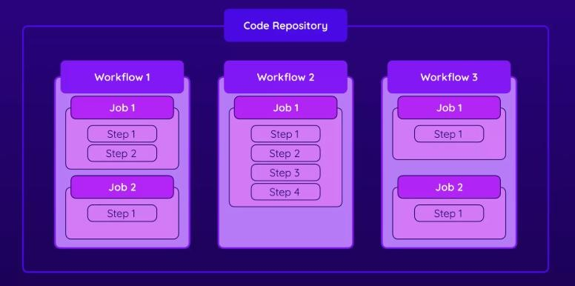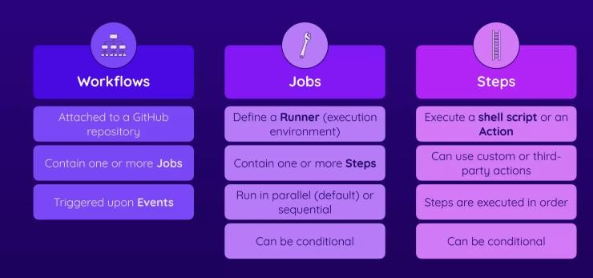

run
:

./deploy.sh

Action
Reusable module performing a specific task. Types: 1. Docker action: runs in container 2. JavaScript action: runs on Node.js 3. Composite action: combines steps Usage:
uses: actions/checkout@v4
# Format: owner/repo@version or owner/repo/path@version
Common Actions:

Action | Purpose
actions/checkout@v4 | Clone repository code
actions/setup-node@v4 | Set up Node.js environment
actions/upload-artifact@v4 | Store build artifacts
actions/download-artifact@v4 | Retrieve stored artifacts

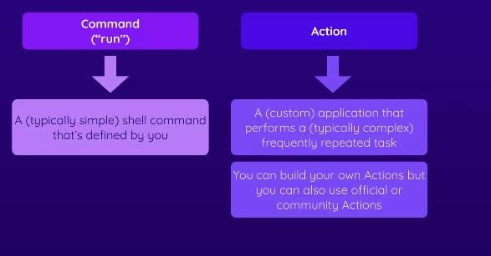

Runner
A machine (hosted or self-hosted) that executes jobs.
GitHub-Hosted Runners:
runs-on: ubuntu-latest # Linux runs-on: windows-latest # Windows runs-on: macos-latest # macOS Self-Hosted Runners:
runs-on: [self-hosted, linux, x64, gpu] # Labels you define

Events (Triggers)
GitHub events that start workflows.
Common Events:
on: push: branches: [main, develop] paths: ['src/**', 'package.json']
pull_request:
branches: [main]
schedule:
- cron: '0 9 * * 1' # Every Monday at 9 AM UTC
workflow_dispatch: # Manual trigger via UI
release: types: [published]

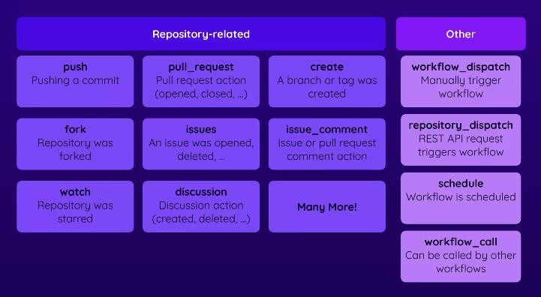

1.4 Architecture Diagram: End-to-End Flow
Developer pushes code to GitHub
│
↓
GitHub detects event (push, PR, schedule)
│
↓
Workflow triggered (.github/workflows/ci.yml)
│
├─→ Job 1: Build (ubuntu-latest runner)
│ ├─ Checkout code
│ ├─ Install dependencies
│ ├─ Compile/build
│ └─ Upload artifact
│
├─→ Job 2: Test (ubuntu-latest runner)
│ ├─ Download artifact
│ ├─ Run unit tests
│ ├─ Run integration tests
│ └─ Generate test report
│
└─→ Job 3: Deploy (Ubuntu runner, needs: [build, test])
├─ Download artifact
├─ Deploy to production
└─ Send Slack notification

All logs available in GitHub UI → Actions tab

Key Learnings:
Workflow files live in .github/workflows/
YAML syntax and proper indentation matter Logs are visible in GitHub UI
workflow_dispatch allows manual triggers Multiple events can trigger the same workflow
1.6 Summary and Key Takeaways  Concept | Key Point
Workflow | YAML file that defines the entire automation
Jobs | Run in parallel; ordered with needs:
Steps | Individual tasks (shell commands or actions)
Actions | Reusable marketplace modules
Runners | Machines executing workflows (GitHubhosted or self-hosted)
Events | GitHub events triggering workflows (push, PR, schedule)
Jenkins vs Actions | SCM-native, distributed, no controller server needed

